Marty Miller

~~In Concert~~

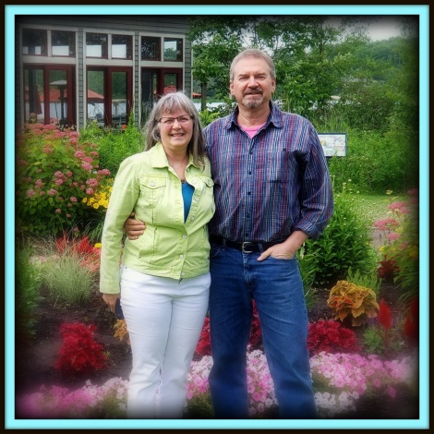

Singer

Song writer

Guitarist

Marty and Janet will be coming to our church to present a concert of music and testimony from the heart. Marty sings and Jan runs their sound. Marty has an honest, relaxed style, from exciting praise to serious soul searching.
Take this opportunity now to start inviting your friends and family!!

The Concert will begin at _____ on ___________

Please be praying for this timely event
Marty Miller

~~In Concert~~

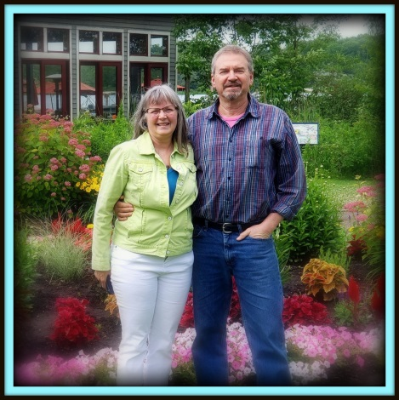

Singer

Song writer

Guitarist

Marty and Janet will be coming to our church to present a concert of music and testimony from the heart. Marty sings and Jan runs their sound. Marty has an honest, relaxed style, from exciting praise to serious soul searching.
Take this opportunity now to start inviting your friends and family!!

The Concert will begin at _____ on ___________

Please be praying for this timely event

